**Lab Exercise 18- Scanning IaC Templates for Vulnerabilities**

**Objective**

* Learn how to scan Infrastructure as Code (IaC) templates for security vulnerabilities.
* Use open-source IaC security tools to detect misconfigurations.
* Understand common risks such as public access, unencrypted resources, and insecure network rules.

**Prerequisites**

* A Linux/Windows/Mac machine with:
  + Terraform installed (for sample IaC)
  + **Checkov** (pip install checkov) or **tfsec** (brew install tfsec or binary download)
* Git installed (optional, for version control of IaC templates)

**Output:-**

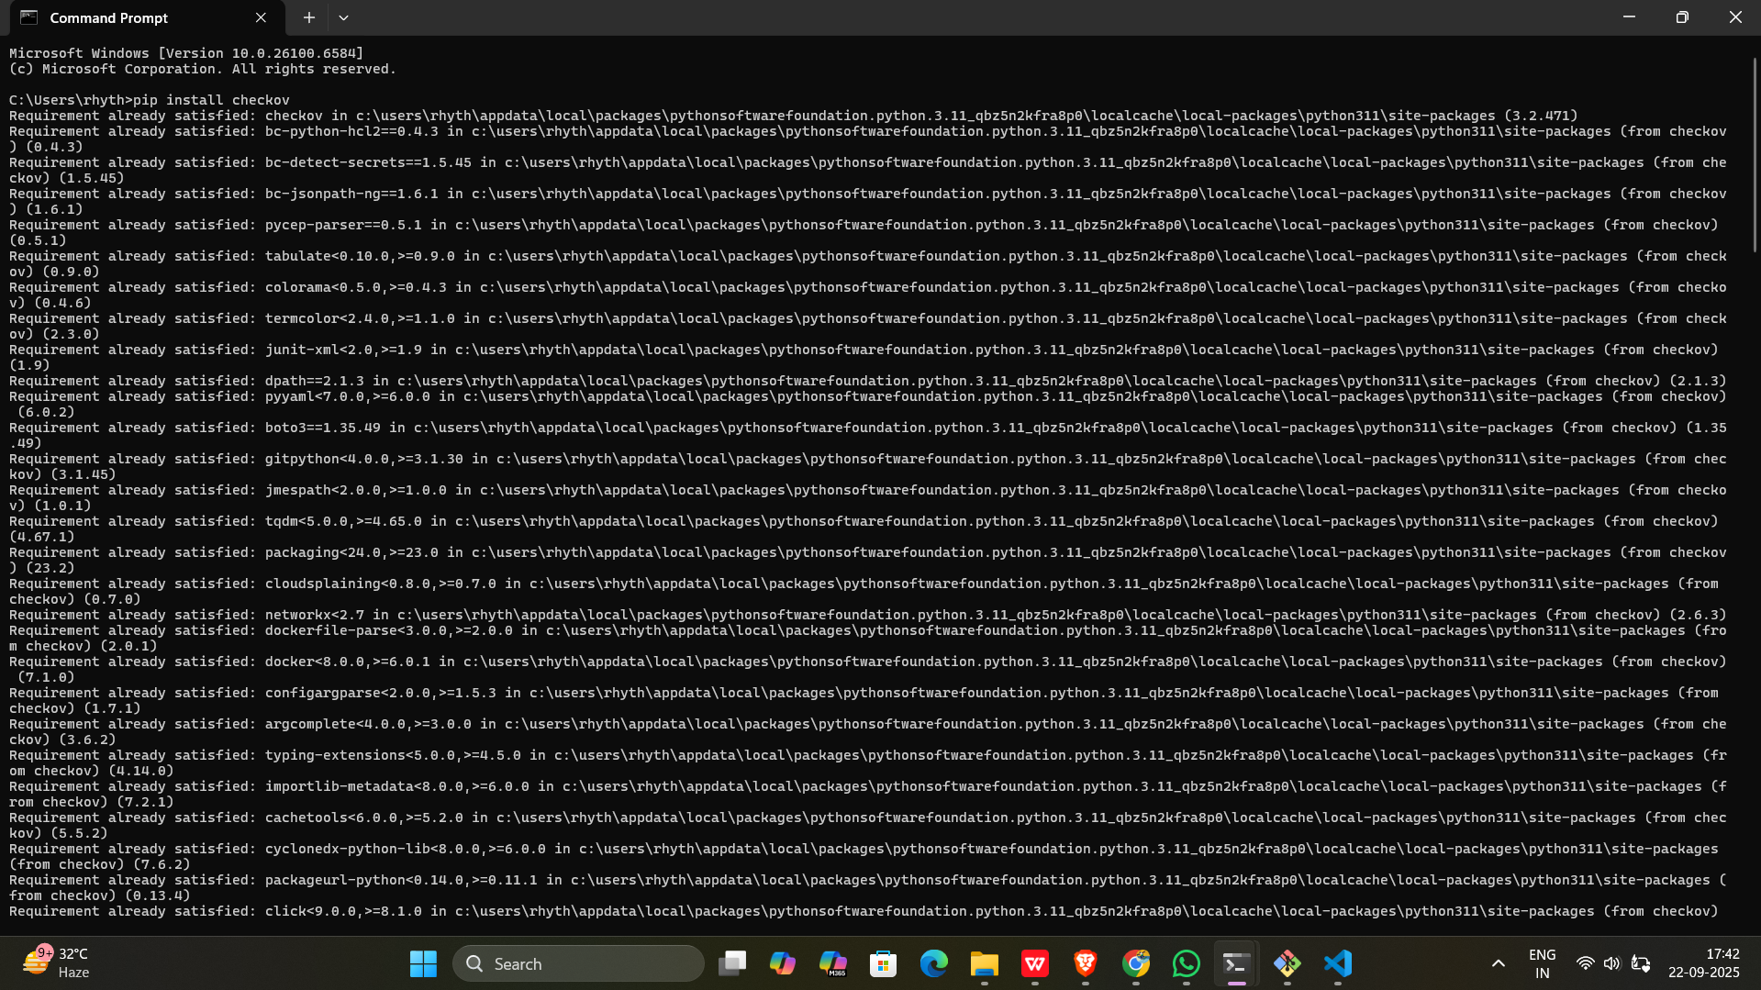

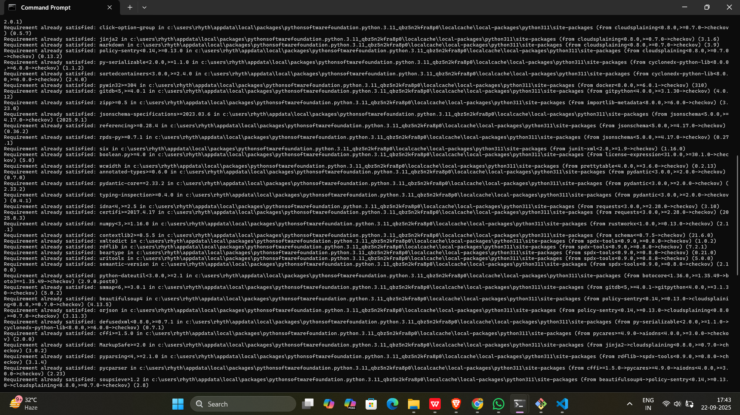

Setting environment variables (checkov not recognized)

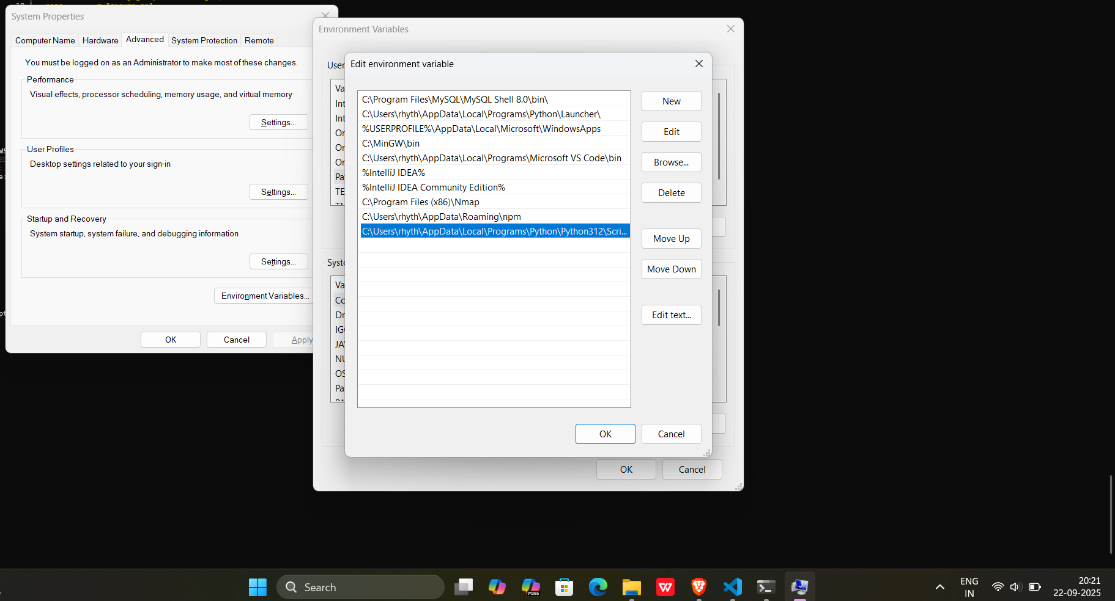

**Step 1: Create an Insecure IaC Template**

Create a file named main.tf with the following Terraform code:

provider "aws" {

region = "us-east-1"

}

resource "aws_s3_bucket" "insecure_bucket" {

bucket = "my-insecure-bucket-lab"

acl = "public-read"

}

resource "aws_security_group" "insecure_sg" {

name = "insecure-sg"

description = "Allow all inbound traffic"

ingress {

from_port = 0

to_port = 65535

protocol = "tcp"

cidr_blocks = ["0.0.0.0/0"]

}

}

**Output:-**

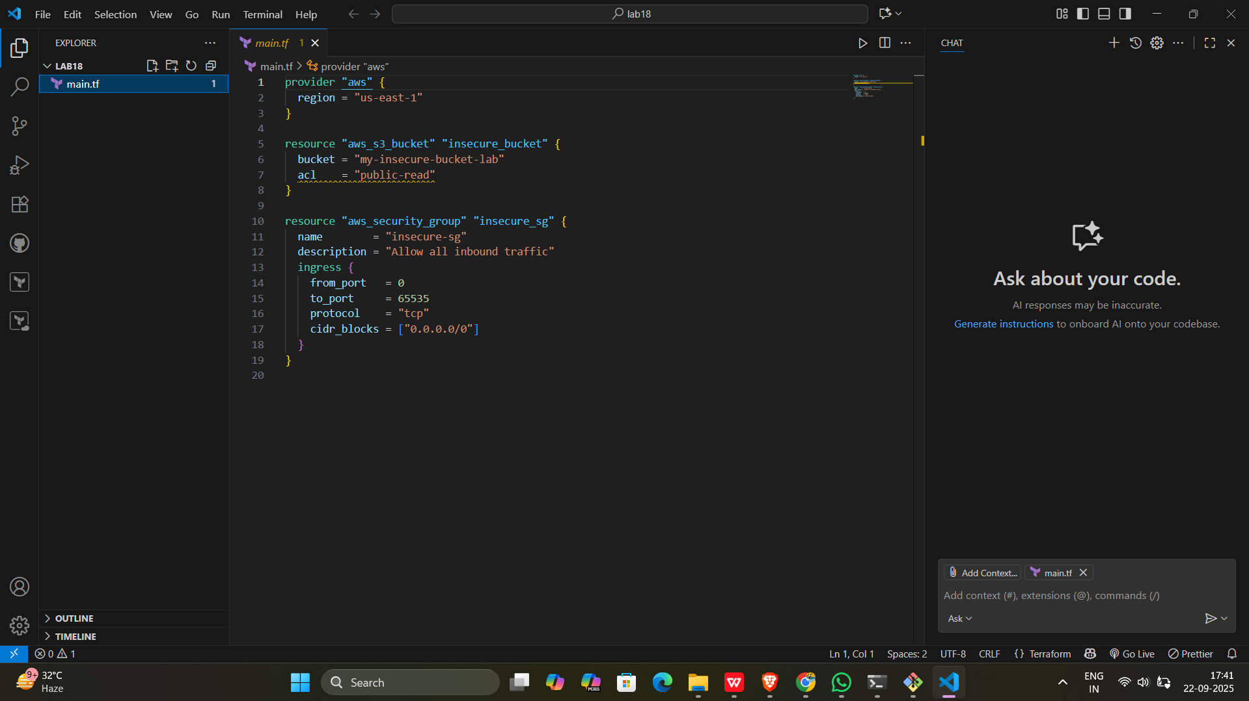

**Step 2: Scan the Template with Checkov**

Run Checkov on the current directory:

checkov -d .

**Expected Findings:**

* Public S3 bucket access (public-read)
* Security group open to all inbound traffic

**Expected Findings:**

* Warns about S3 bucket without encryption
* Flags open Security Group rules

**Step 4: Review the Report**

Example output (Checkov):

Check: CKV_AWS_20: "S3 Bucket allows public read access"

FAILED for resource: aws_s3_bucket.insecure_bucket

Check: CKV_AWS_260: "Security group allows ingress from 0.0.0.0/0"

FAILED for resource: aws_security_group.insecure_sg

**Output:-**

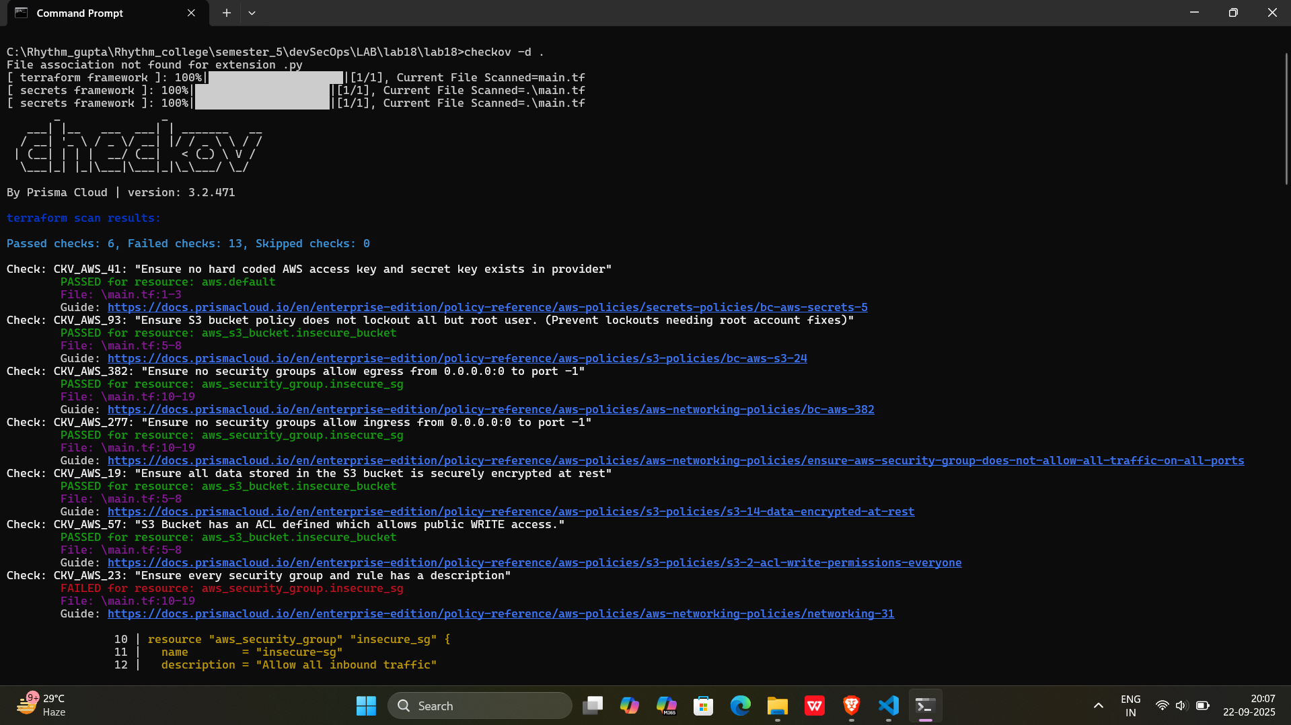

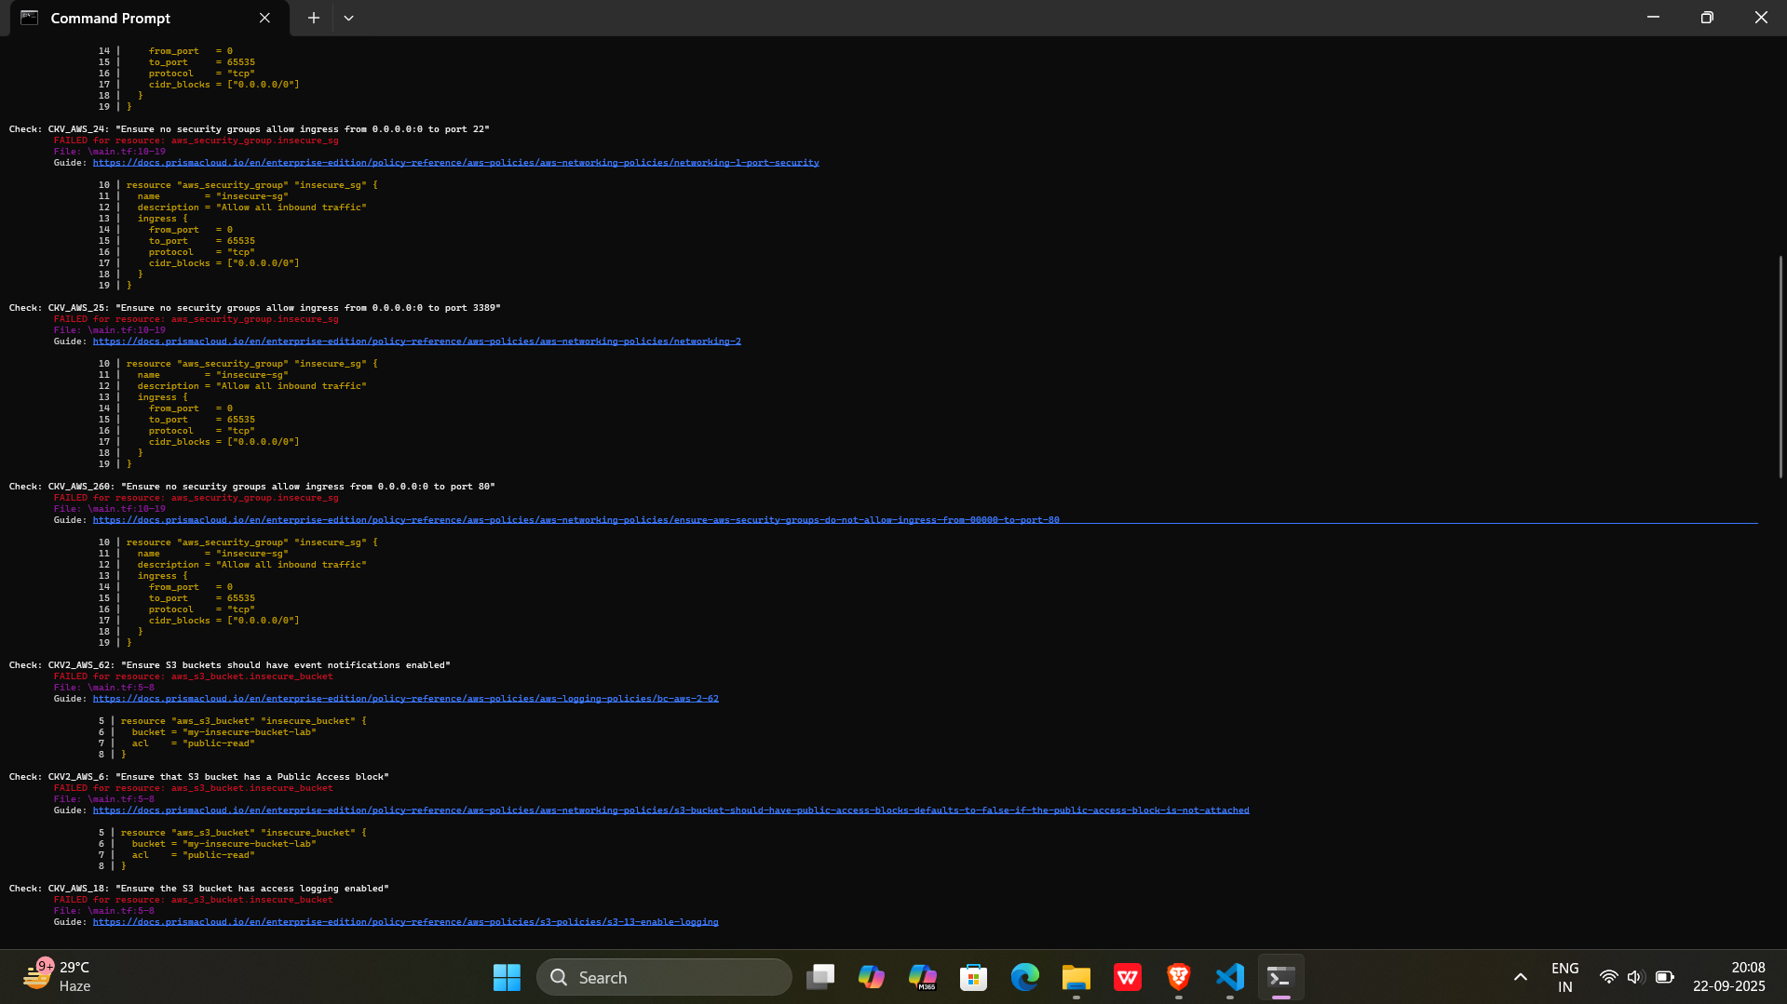

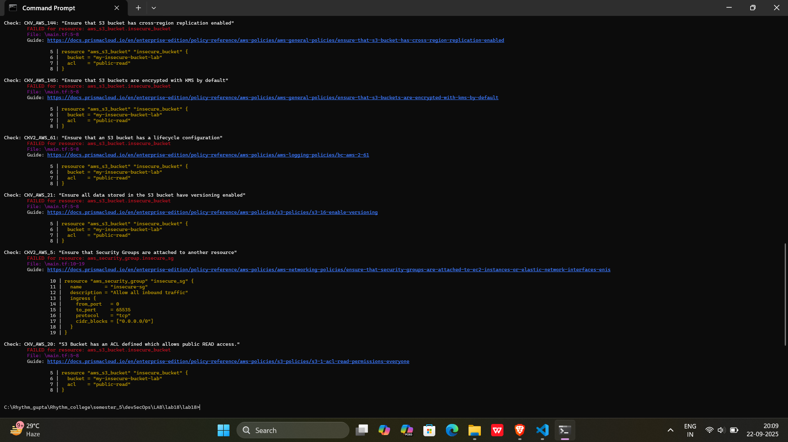

**Step 5: Apply Fixes (Optional)**

Modify the IaC template to:

* Set S3 bucket ACL to private
* Enable encryption (AES256)
* Restrict Security Group to specific IP ranges

**Output:-**

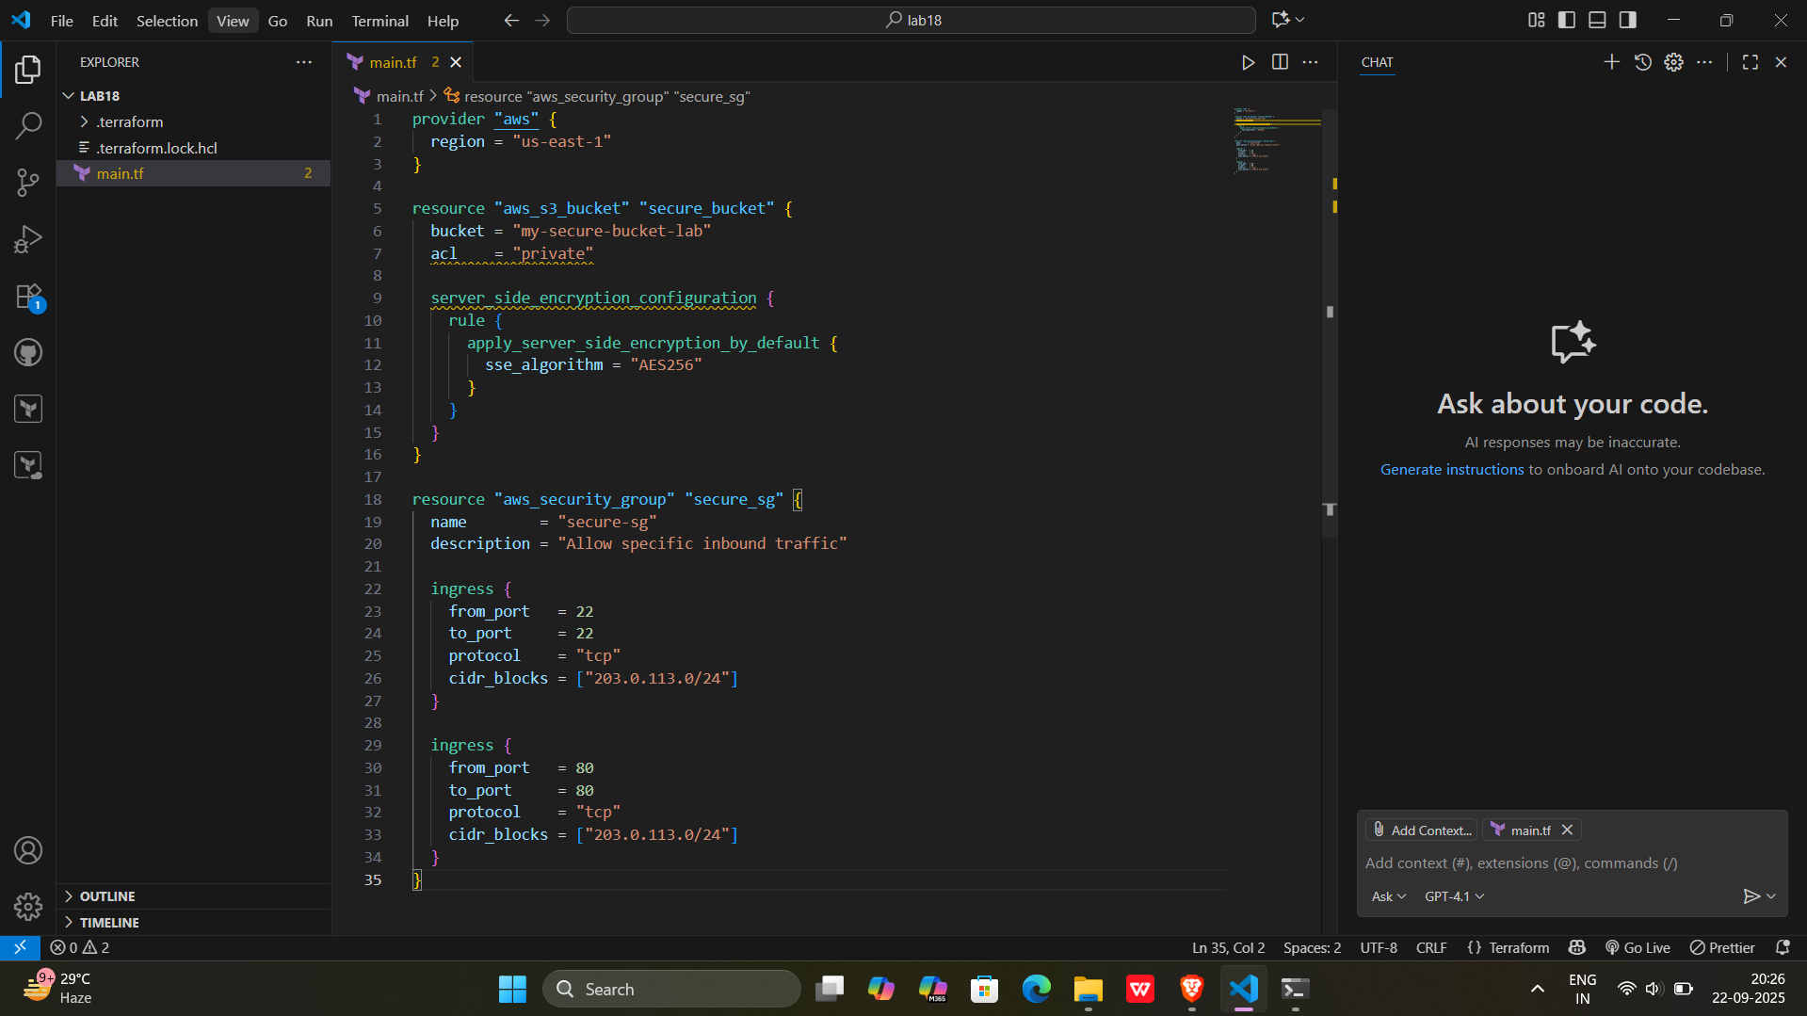

**Step 6: Rescan the Template**

Run the scan again:

checkov -d .

Now the findings should be **resolved or reduced**.

**Output:-**

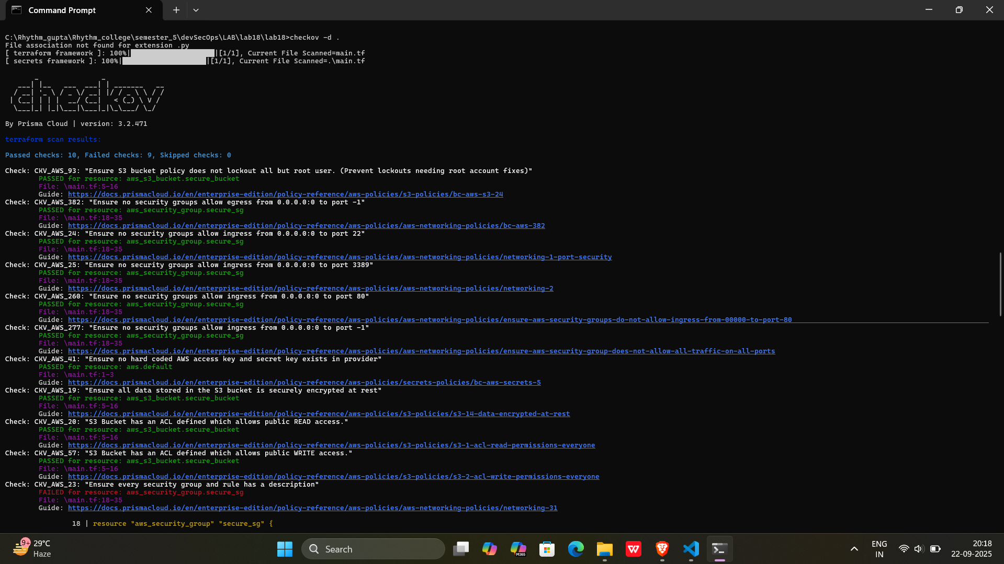

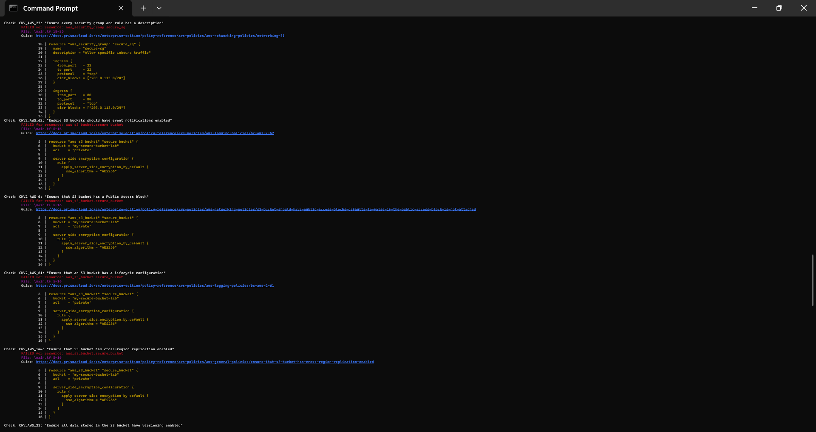

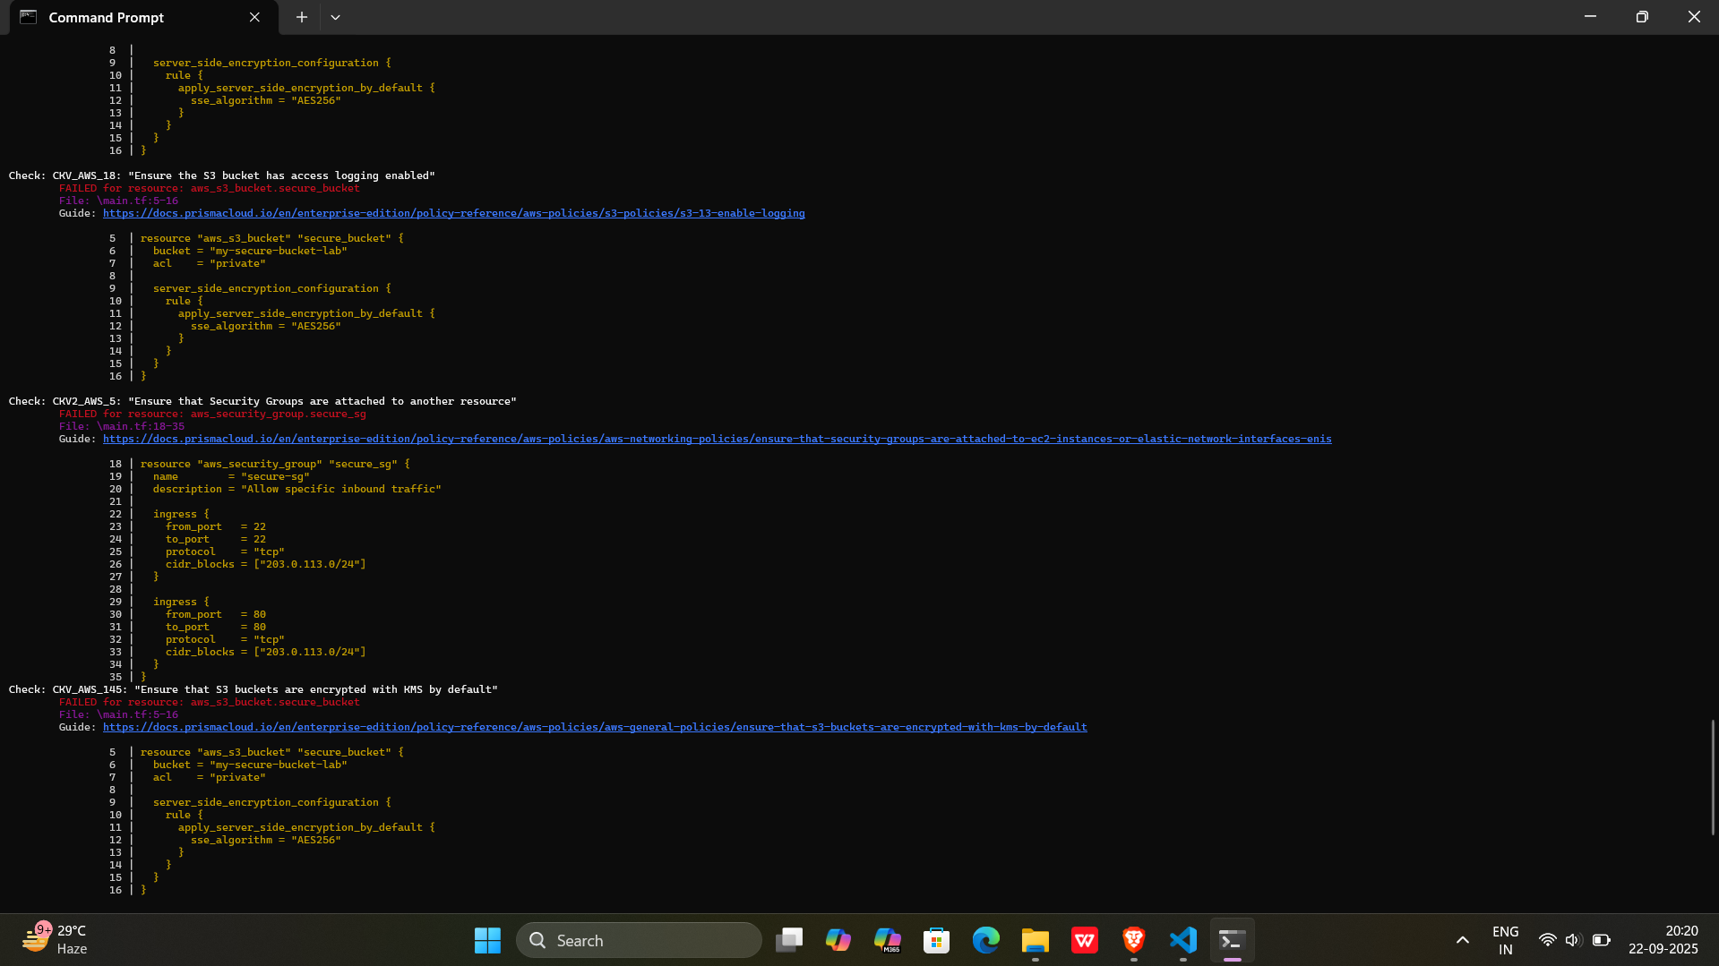

**Step 7: Document Findings**

Create a simple findings log:

**Output:-**

|  |  |  |  |
| --- | --- | --- | --- |
| Finding/Issue | Checkov ID | File & Line | Status |
| S3 bucket ACL is public-read | CKV_AWS_18 | main.tf: 6 | **Resolved** |
| S3 bucket is not encrypted | CKV_AWS_19 | main.tf: 6 | **Resolved** |
| Security group allows all ingress traffic | CKV_AWS_382 | main.tf: 12 | **Resolved** |